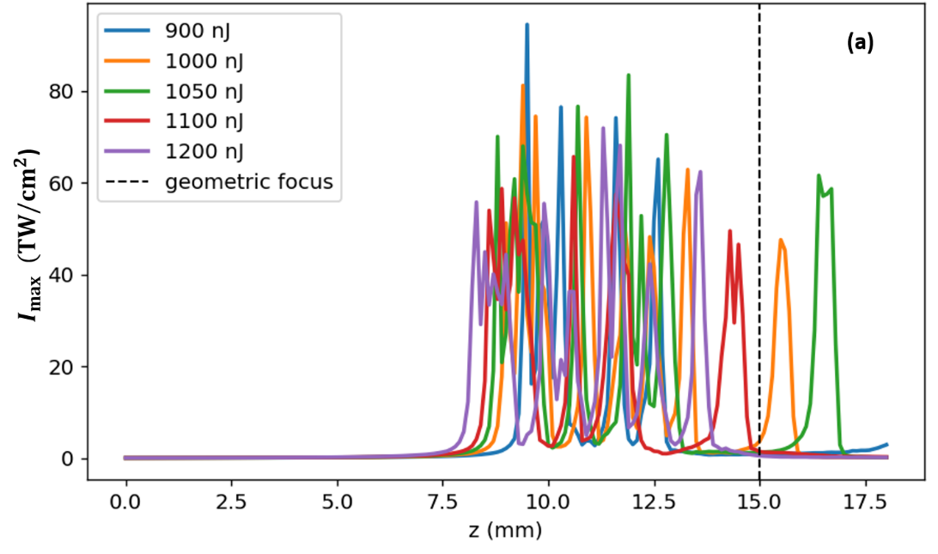
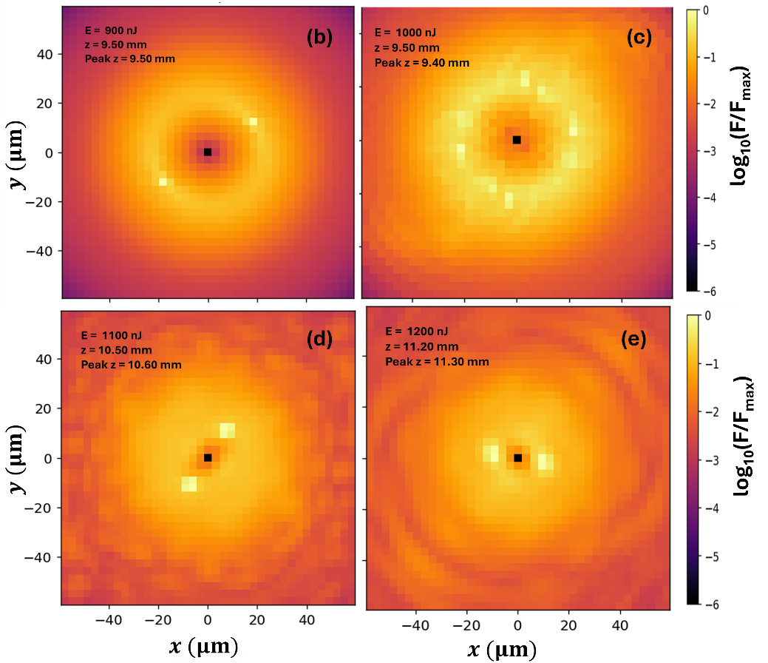
Figure 1. Fused-silica vortex validation. (a) Maximum intensity I_{max}(z) for focused m=1 vortex pulse in fused silica. The dashed vertical line indicates the geometrical focus at f=15 mm. (b–e) Zoomed logarithmic fluence maps near the nonlinear focus for selected input energies. The maps are normalized as log₁₀(F/F_{max}). The formation of azimuthal hot spots on the vortex ring indicates nonlinear ring modulation and vortex-breakup dynamics.

